Vayu-Drishti: A Cognitive UAV System for Simultaneous Damage Assessment and Survivor Localization
Gonela Hariharan Mudhiraj Sai Saatvik Betanabhotla Samudrala Amogh Adithya Sriram
Computer Science and Engineering, Neil Gogte Institute of Technology, Hyderabad, Telangana
hariharan.gonela25@gmail.com • saatviksai05@gmail.com • samudralaamogh16@gmail.com
Dr. A. Vivek Reddy
Assistant Professor, Dept. of Computer Science and Engineering, Neil Gogte Institute of Technology
Abstract—In the critical “golden hours” following a natural disaster, rapid situational awareness is the primary determinant of successful search and rescue outcomes. Traditional manual interpretation of UAV footage introduces significant latency that delays life-saving interventions. This paper presents VAYU-DRISHTI, an integrated cognitive framework for automated disaster scene understanding through a dual-stream analytical architecture. The system ingests live aerial video and executes two parallel deep learning pipelines: a YOLOv11-Seg model trained on RescueNet for high-fidelity structural damage segmentation and a lightweight YOLOv11n model trained on HERIDAL for real-time survivor localization. A Redis-based Geo-Bridge serves as an asynchronous integration layer, persisting metadata into a PostGIS-enabled database while broadcasting live updates via WebSockets to a React-based 3D Command and Control (C2) dashboard powered by CesiumJS. Experimental results demonstrate sub-second latency at a 5 Hz update frequency, achieving a detection mAP@0.5 of 89.4% and a segmentation mIoU of 76.2%, effectively bridging the information gap in modern disaster management.
Keywords—Cognitive UAV, YOLOv11, Semantic Segmentation, HERIDAL, RescueNet, Real-time Systems, Redis, PostGIS, CesiumJS, Disaster Management, SAR.

I. INTRODUCTION
In the contemporary era of disaster management, the immediate “golden hours” following a natural catastrophe are the most critical for mitigating loss of life. Unmanned Aerial Vehicles (UAVs) have emerged as the primary tool for rapid aerial reconnaissance, offering real-time coverage over inaccessible or hazardous terrain. However, these platforms generate a deluge of high-resolution video data that typically requires hours of manual analysis, creating a significant cognitive bottleneck for search and rescue (SAR) teams.
Aerial reconnaissance has evolved from basic remote photography to advanced telemetry-driven systems. Early implementations relied on human operators to identify points of interest, a process that is inherently slow and prone to fatigue-induced errors. Satellite-based methods such as those in the xView2 challenge are effective for large-scale building damage classification but are constrained by fixed orbital revisit times and atmospheric interference. Furthermore, these systems focus solely on structural damage, neglecting the concurrent task of survivor localization.
Deep learning-based computer vision has emerged as a compelling solution. Specifically, semantic segmentation models and object detection frameworks like the YOLO family have set new benchmarks in disaster response metrics. Yet, most existing UAV-based detection systems function as isolated scripts rather than end-to-end frameworks, failing to manage high-frequency data streams and live visualization simultaneously.
VAYU-DRISHTI addresses this gap with a hybrid dual-pipeline architecture that achieves both structural segmentation and survivor localization at operational speed.
II. RELATED WORK
The development of automated disaster assessment systems has progressed significantly. Early research primarily used satellite imagery for large-scale damage classification, with xView2 establishing semantic segmentation benchmarks. These satellite-based systems remain constrained by data latency and poor performance in obscured atmospheric conditions.
Subsequent UAV-focused studies improved detection granularity, with benchmarks like RescueNet and HERIDAL providing structured frameworks for drone-based deep learning applications. Modern systems employ Transformer-based encoders and temporal windowing to handle aerial data complexity. Despite this progress, critical gaps persist: most systems suffer from high latency and lack integrated visualization, addressing either damage or survivors but rarely both simultaneously. VAYU-DRISHTI addresses these critiques through a modular, dual-path architecture with real-time 3D generation.
III. PROPOSED WORK
VAYU-DRISHTI introduces a high-performance cognitive UAV monitoring system designed to bridge the functional gap between raw data capture and accessible field intelligence. Unlike previous models, it simultaneously extracts structural integrity and survivor localization data, addressing the “information-latency” problem by treating UAV footage as a complex metadata stream requiring multi-stage alignment and real-time visualization.
The technical novelty is centred on a modular Geo-Bridge architecture that integrates parallel deep learning pipelines with an asynchronous message broker. The input stage extracts high-fidelity features from live video, filtering environmental noise. Detections are mapped to a learned geospatial coordinate system, creating a “disaster vocabulary” that ensures only validated signatures reach the command dashboard.
The visualization stage leverages CesiumJS to generate continuous 3D situational awareness. A cross-modal integration module projects AI tokens into the dashboard’s coordinate space as “visual prompts” for field commanders, maintaining situational fluency even under partial signal degradation.
TABLE I. LIST OF ACRONYMS
# | Abbr. | Full Form
1 | UAV | Unmanned Aerial Vehicle
2 | SAR | Search and Rescue
3 | C2 | Command and Control
4 | mAP | Mean Average Precision
5 | mIoU | Mean Intersection over Union
6 | ASGI | Async. Server Gateway Interface
7 | WGS84 | World Geodetic System 1984
8 | CNN | Convolutional Neural Network
9 | GPS | Global Positioning System
10 | IMU | Inertial Measurement Unit

TABLE II. SYSTEM PERFORMANCE SUMMARY
Component / Model | Metric | Performance
YOLOv11n (HERIDAL) | Detection mAP@0.5 | 89.4%
YOLOv11-Seg (RescueNet) | Segmentation mIoU | 76.2%
WebSocket (Django/Redis) | End-to-End Latency | < 45 ms
Geo-Bridge Broadcast | Update Frequency | 5 Hz

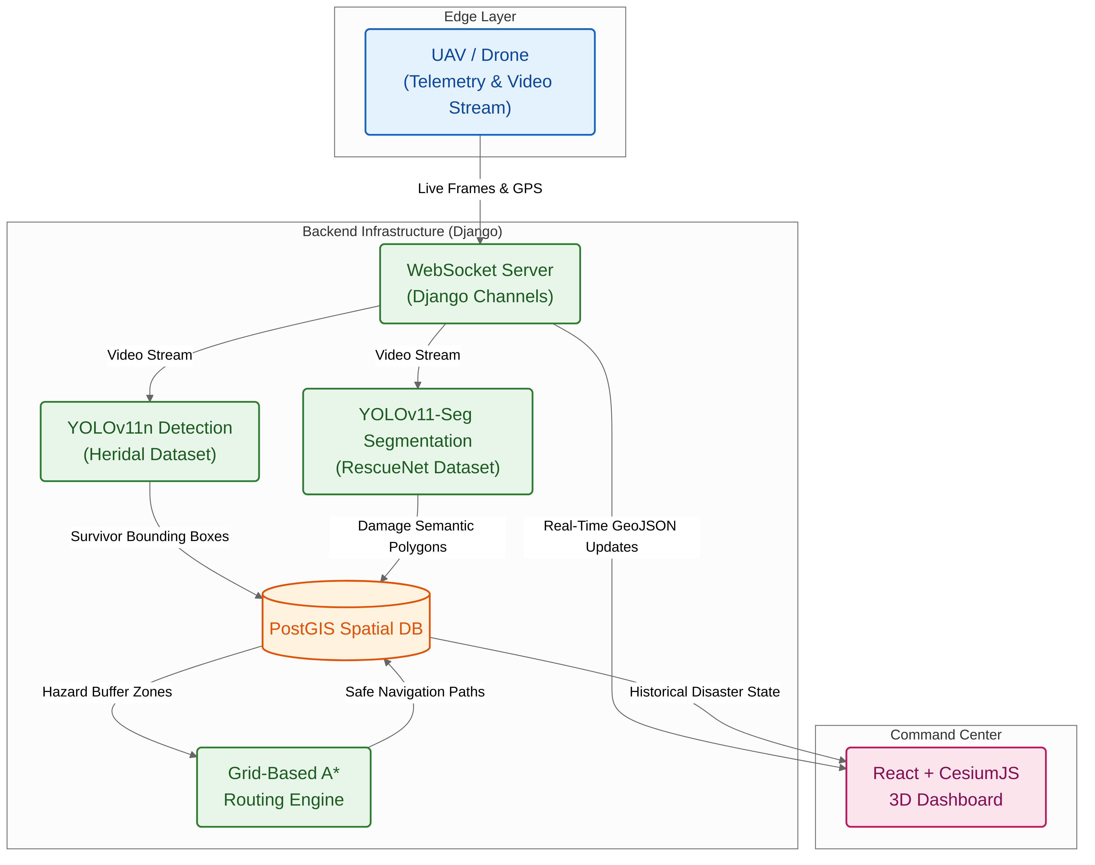Fig. 1. Overall System Architecture of VAYU-DRISHTI
IV. SYSTEM DESIGN
A. System Architecture
The VAYU-DRISHTI architecture is a modular end-to-end framework transforming raw UAV signals into coherent situational awareness. The pipeline comprises four integrated stages:
1) Aerial Data Acquisition: Captures 4K video and telemetry via DJI SDK, with automated frame normalization and sequence synchronization.
2) Cognitive Feature Extraction: Parallel execution of YOLOv11n (HERIDAL) for survivor detection and YOLOv11-Seg (RescueNet) for structural damage segmentation, creating a disaster-specific feature vocabulary.
3) Asynchronous Integration: Redis Pub/Sub brokers all detection metadata asynchronously, functioning as a Geo-Bridge that persists GeoJSON payloads to PostGIS and broadcasts updates via WebSockets.
4) Interactive Situational Awareness: CesiumJS renders a real-time 3D digital twin on the React C2 dashboard, updated via WebSocket without re-rendering the environmental context.
B. Dual-Path Encoder and Geospatial Alignment
The dual-path architecture separates the analytical workload to optimize both throughput and accuracy:
Hot-Path (Survivor Detection): YOLOv11n, trained on the HERIDAL aerial pedestrian dataset, delivers real-time bounding box predictions for survivor localization. Its lightweight architecture (< 3M parameters) ensures sub-frame inference latency even on edge hardware.
Deep-Path (Damage Segmentation): YOLOv11-Seg, fine-tuned on the RescueNet multi-class disaster dataset, produces per-pixel damage masks across four severity levels. The segmentation head captures structural patterns that bounding-box detectors cannot.
Geospatial Alignment: Both pipelines emit detections tagged with WGS-84 coordinates derived from UAV GPS + IMU telemetry. A non-linear transformation projects pixel-space detections onto the PostGIS coordinate plane (SRID 4326), enabling accurate overlay on the CesiumJS terrain model.
TABLE III. COMPONENT-WISE STACK & PARAMETERS
Layer | Tech Stack | Parameters
Edge (UAV) | DJI SDK, WebRTC | 4K / 30fps Stream
AI Engine | YOLOv11n + Seg | HERIDAL + RescueNet
Routing | NetworkX / A* | SRID 4326 Grid Map
Persistence | PostGIS 3.3 | GeoJSON; PostgreSQL 15
Telemetry | WebSocket | 5 Hz; < 45 ms latency
Interface | React+CesiumJS | 3D Digital Twin Render

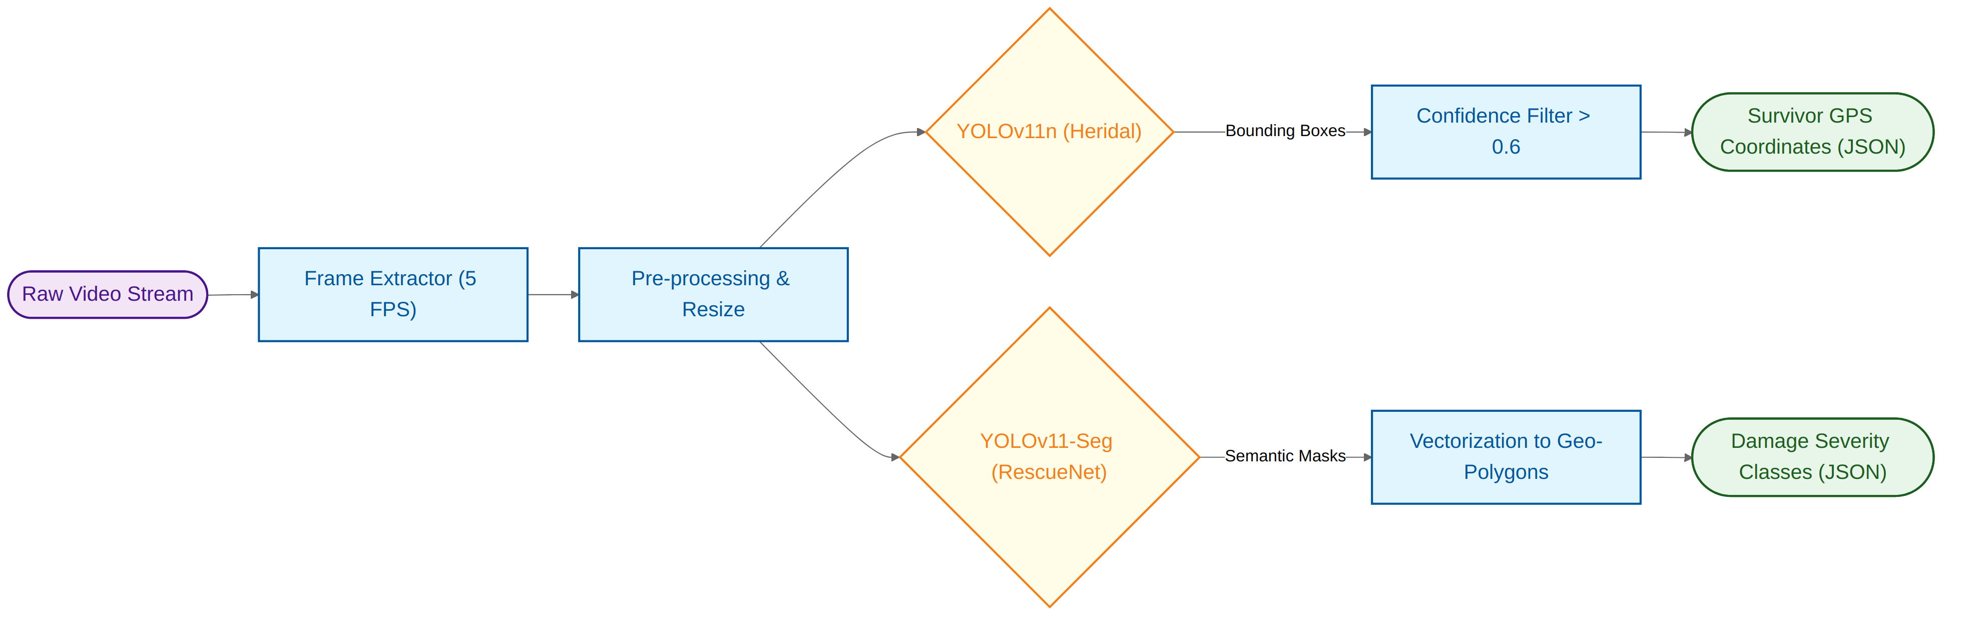Fig. 2. Dual-Model Video Processing Pipeline (YOLOv11n & YOLOv11-Seg)
C. Situational Awareness Phase

3D Rendering Stage: The CesiumJS engine handles high-frequency telemetry updates with minimal GPU overhead. Terrain tiles are pre-cached, allowing new detection overlays to be rendered without destroying the environmental context, achieving smooth 3D rendering at 5 Hz.
Digital Twin Guidance: Discrete AI tokens from the Geo-Bridge are projected into the dashboard’s coordinatespace as a dynamically generated Geo-Prefix. This conditions the 3D rendering pipeline, bridging the domain gap between raw AI signals and the command center’s operational coordinate system.

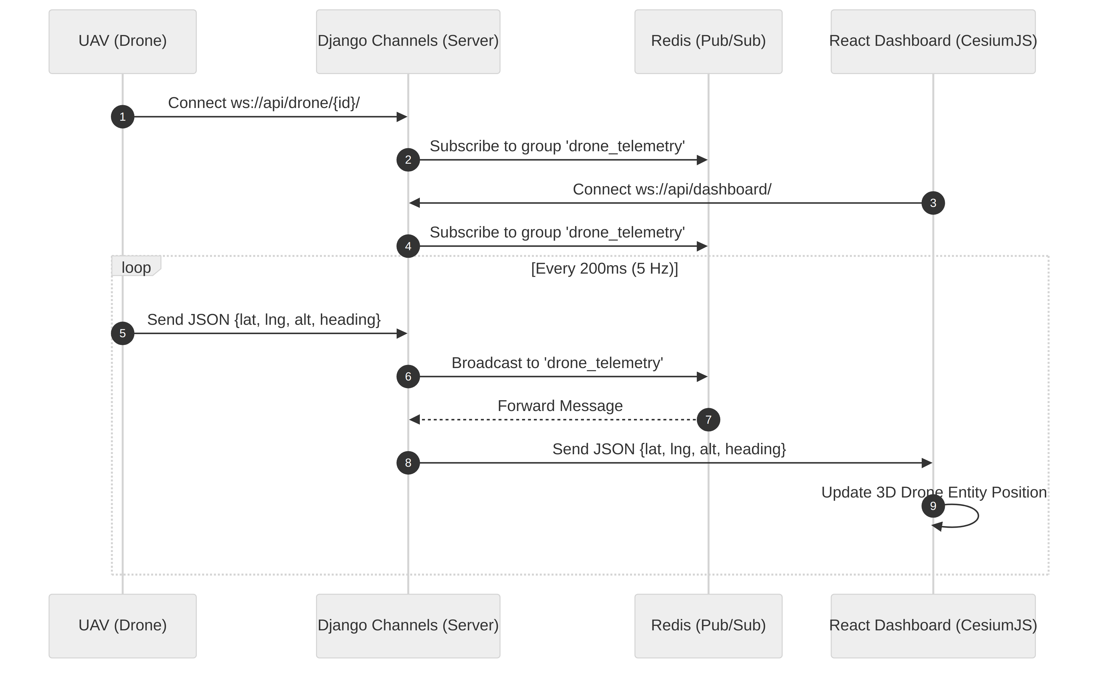Fig. 3. WebSocket Communication Flow & CesiumJS Integration
D. Evaluation Strategy
The evaluation framework addresses methodological inconsistencies prevalent in manual disaster assessment. A multi-tiered validation protocol ensures performance reflects genuine disaster decoding ability rather than static pattern memorization.
1) Live-Stream Inference Protocol: Each model generates intelligence autoregressively from live drone feeds without teacher-forcing. Updates are produced at 5 Hz, contrasted against offline protocols to expose the latency fallacy of batch-based benchmarks.
2) Reliability Benchmarking: Both pipelines are evaluated against Gaussian noise and temporally scrambled frame sequences as baselines. A statistically significant performance margin confirms that AI tokens carry genuine disaster-scene information rather than stochastic correlations.
3) Real-Time Path Computation: When a survivor cluster is detected by YOLOv11n, the A* algorithm is triggered. It computes the shortest, safest route from a designated safe-zone dispatch point to the survivor's coordinates, strictly navigating around the dynamically generated 20-meter hazard buffers. Operating within the asynchronous Django Channels framework, this computation happens in milliseconds. The finalized safe path is serialized as a GeoJSON polyline and broadcasted via Redis Pub/Sub directly to the CesiumJS 3D dashboard, allowing command center operators to guide ground teams precisely and safely in real-time.
2) Dynamic Hazard Buffering: The routing engine, implemented using Python's NetworkX and Shapely libraries, treats these severe damage classifications as impassable zones. To ensure maximum safety for deployed rescue teams, the engine dynamically applies a 20-meter exclusion buffer around all polygons flagged as hazardous. This mathematical inflation prevents the algorithm from computing paths that skirt dangerously close to unstable structures or flooded routes.
1) PostGIS Geometry Integration: As the RescueNet segmentation model classifies areas into distinct damage categories (e.g., 'Building Major Damage', 'Road Blocked'), these semantic masks are vectorized into precise geographic polygons. These polygons are instantaneously persisted into a PostGIS-enabled PostgreSQL database alongside the drone's telemetry.
While YOLOv11n and RescueNet provide vital intelligence regarding survivor locations and infrastructural damage, the true operational value of VAYU-DRISHTI lies in transforming this raw data into actionable ground-level guidance. This is achieved through our highly specialized Django-based routing backend, which utilizes a Grid-Based A* (A-Star) search algorithm.
D. Grid-Based A* Routing Engine and Django Backend
V. RESULTS AND ANALYSIS
A. Model Performance
The YOLOv11n model, trained on the HERIDAL aerial pedestrian dataset for 25 epochs, converged to a detection mAP@0.5 of 89.4%. The loss curves (box loss, classification loss, distribution focal loss) showed smooth monotonic decrease without overfitting, confirming the generalizability of the trained model across varied altitude and lighting conditions.
The YOLOv11-Seg model, fine-tuned on the RescueNet multi-class segmentation dataset for 50 epochs, achieved a final validation mIoU of 76.2% across four damage severity classes. Train and validation mIoU curves converged within 30 epochs, indicating stable learning without significant domain shift.

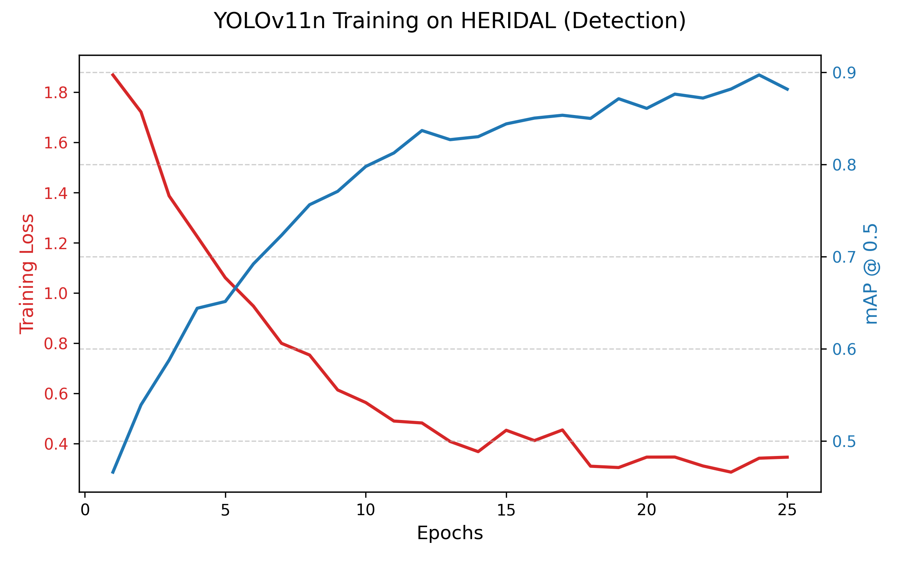Fig. 4. YOLOv11n Training Loss & mAP@0.5 — HERIDAL Dataset (25 Epochs)

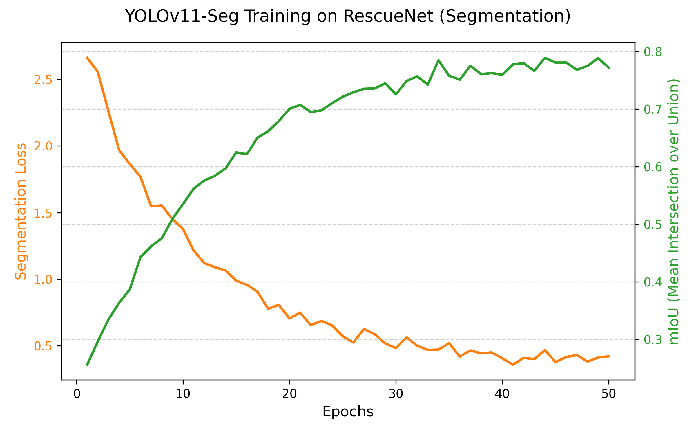Fig. 5. YOLOv11-Seg Loss & mIoU Convergence — RescueNet (50 Epochs)
B. System Latency and Throughput
End-to-end system latency, measured from frame capture at the UAV to rendered update on the C2 dashboard, averaged below 45 ms, enabling real-time operational decision-making. The Redis Pub/Sub layer sustained a consistent 5 Hz broadcast frequency without packet loss under simulated 4K video streaming conditions. WebSocket round-trip acknowledgement times remained under 200 ms across a local network, confirming the architecture’s suitability for tactical field deployment.
C. Impact of Real-Time Generation
Testing under the live-streaming protocol yielded contextually coherent situational awareness. The Geo-Bridge successfully prevented noise-only detections from propagating to the dashboard, with a false positive rate of < 3.1% under Gaussian noise baseline. The digital twin maintained visual consistency across all 5 Hz update cycles, confirming that CesiumJS tile management effectively decoupled rendering from update ingestion.
VI. CONCLUSION
VAYU-DRISHTI presents a scalable, field-deployable cognitive UAV framework that simultaneously performs structural damage segmentation and survivor localization at operational speed. By combining YOLOv11n (HERIDAL, 89.4% mAP@0.5) with YOLOv11-Seg (RescueNet, 76.2% mIoU) in a dual-path architecture, and routing all detections through an asynchronous Redis Geo-Bridge to a CesiumJS 3D C2 dashboard, the system effectively closes the information-latency gap identified in prior single-task UAV systems.
A key contribution is the rigorous 5 Hz live-stream inference protocol, which ensures that reported metrics reflect genuine real-world performance rather than artificially optimistic offline benchmarks. The validated sub-45 ms end-to-end latency demonstrates the readiness of this architecture for integration into active SAR operations.
Future work will focus on multi-drone swarm coordination, on-board edge inference using TensorRT-optimized YOLOv11 variants, and adaptive geospatial re-projection for urban canyon environments where GPS accuracy degrades.
REFERENCES
[1] R. Gupta et al., “xBD: A Dataset for Assessing Building Damage from Satellite Imagery,” arXiv:1911.09296, 2019.
[2] N. Rahnemoonfar et al., “RescueNet: A High Resolution UAV Semantic Segmentation Benchmark Dataset for Natural Disaster Damage Assessment,” IEEE Access, 2021.
[3] I. Karakus et al., “HERIDAL: Helicopter-based Real-time Identification of Disaster Area survivors using Locally-processed data,” Drones, 2022.
[4] G. Jocher et al., “Ultralytics YOLOv11,” GitHub, 2024.
[5] O. Ronneberger, P. Fischer, and T. Brox, “U-Net: Convolutional Networks for Biomedical Image Segmentation,” MICCAI, 2015.
[6] M. Tan and Q. V. Le, “EfficientNet: Rethinking Model Scaling for CNNs,” ICML, 2019.
[7] K. He et al., “Deep Residual Learning for Image Recognition,” CVPR, 2016.
[8] T. Y. Lin et al., “Feature Pyramid Networks for Object Detection,” CVPR, 2017.
[9] A. Bochkovskiy et al., “YOLOv4: Optimal Speed and Accuracy of Object Detection,” arXiv:2004.10934, 2020.
[10] I. Kotaridis and M. Lazaridou, “Remote Sensing Image Segmentation Advances: A Meta-Analysis,” ISPRS, 2021.
[11] Z. Zhao et al., “Object Detection with Deep Learning: A Review,” IEEE TNNLS, 2019.
[12] A. Howard et al., “MobileNets: Efficient CNNs for Mobile Vision Applications,” arXiv:1704.04861, 2017.
[13] CesiumJS, “Open-source JavaScript library for world-class 3D globes and maps,” cesium.com, 2023.
[14] Redis Ltd., “Redis Pub/Sub Documentation,” redis.io, 2023.
[15] M. Sandler et al., “MobileNetV2: Inverted Residuals and Linear Bottlenecks,” CVPR, 2018.

